Combining Sanborn Worksheet and K4, like Zola?

http://scirealm.org/COFzola.html
 | Covert Operations Fragment  Left side | Zola (original)  Right side
 | 123456789012345678 | 123456789012345678
01  02  03  04  05  06  07  08  09  10  11  12  13  14  15  16 | DINEHYODTTSATEOSL  EGTTPECLEEHTFESOAT  NHOWSOUNPBDEHRSLD  PHSRADDSEICADSEDE  ELBAEAEALGSTOHASR  EAEPEECEFAVEWTCED  IIOIAPSSHDMHYNEAN  ITLDJYOANIMLEUTECL  OEASSNEACANDEBEYU  LIEPCNTAREHOERELD  SSAEETAIETDCODAWE  ERDARIWODNREEHNY  OEHTDLATRBIRULOTT  HTNOADESNEEETWPEI  NEIADIEISCWOLRSMGC  XAEAEELGAITETAADX | NSSEBDBHRTSODULL  PSAYOAUMEWTBAWW  ESESNLKPLEHEIWYY  OIEGWRPRNIDOTWEE  ELPWSACEHIHRATPP  LFLHMHATNEWAEHR  TUEDTHFASOOWCDTT  GAUAWRDMEERMHLL  ISATDDSODTORERSSS  NSRLOHNNAARMEMOO  ENCAFTRRIALVTILLLL  NTTUELHNAYRADESIII  DEICETEKRVBNOFSSS  HWNNLVTEADFIEAEEE  DGLKRNSHIRAPSEEE  NNITTARNNHULRGTT

 | Covert Operations Fragment - Zola (together)
 | 123456789012345678901234567890123456
01  02  03  04  05  06  07  08  09  10  11  12  13  14  15  16 | DINEHYODTTSATEOSLNSSEBDBHRTSODULL  EGTTPECLEEHTFESOATPSAYOAUMEWTBAWW  NHOWSOUNPBDEHRSLDESESNLKPLEHEIWYY  PHSRADDSEICADSEDEOIEGWRPRNIDOTWEE  ELBAEAEALGSTOHASRELPWSACEHIHRATPP  EAEPEECEFAVEWTCEDLFLHMHATNEWAEHR  IIOIAPSSHDMHYNEANTUEDTHFASOOWCDTT  ITLDJYOANIMLEUTECLGAUAWRDMEERMHLL  OEASSNEACANDEBEYUISATDDSODTORERSSS  LIEPCNTAREHOERELDNSRLOHNNAARMEMOO  SSAEETAIETDCODAWEENCAFTRRIALVTILLLL  ERDARIWODNREEHNYNTTUELHNAYRADESIII  OEHTDLATRBIRULOTTDEICETEKRVBNOFSSS  HTNOADESNEEETWPEIHWNNLVTEADFIEAEEE  NEIADIEISCWOLRSMGCDGLKRNSHIRAPSEEE  XAEAEELGAITETAADXNNITTARNNHULRGTT

 | Covert Operations Fragment - Zola (trimmed)
 | 123456789012345678901234567890123456
01  02  03  04  05  06  07  08  09  10  11  12  13  14  15  16 | DINEHYODTTSATEOSLNSSEBDBHRTSODUL  EGTTPECLEEHTFESOATPSAYOAUMEWTBAW  NHOWSOUNPBDEHRSLDESESNLKPLEHEIWY  PHSRADDSEICADSEDEOIEGWRPRNIDOTWE  ELBAEAEALGSTOHASRELPWSACEHIHRATP  EAEPEECEFAVEWTCEDLFLHMHATNEWAEHR  IIOIAPSSHDMHYNEANTUEDTHFASOOWCDT  ITLDJYOANIMLEUTECLGAUAWRDMEERMHL  OEASSNEACANDEBEYUISATDDSODTORERS  LIEPCNTAREHOERELDNSRLOHNNAARMEMO  SSAEETAIETDCODAWEENCAFTRRIALVTIL  ERDARIWODNREEHNYNTTUELHNAYRADESI  OEHTDLATRBIRULOTTDEICETEKRVBNOFS  HTNOADESNEEETWPEIHWNNLVTEADFIEAE  NEIADIEISCWOLRSMGCDGLKRNSHIRAPSE  XAEAEELGAITETAADXNNITTARNNHULRGT
After removing the extraneous/repeated end characters, the Zola fragments decode to *another* version of Howard Carter's account in his discovery to King Tut's tomb:
 | Covert Operations Fragment - Zola (decoded)
 | 123456789012345678901234567890123456
01  02  03  04  05  06  07  08  09  10  11  12  13  14  15  16 | SLOWLYDESPERATELYSLOWLYITSEEMEDT  OUSASWEWATCHEDTHEREMAINSOFPASSAG  EDEBRISTHATENCUMBEREDTHELOWERPAR  TOFTHEDOORWAYWEREREMOVEDUNTILATL  ASTWEHADTHEWHOLEDOORCLEARBEFOREU  STHEDECISIVEMOMENTHADARRIVEDWITH  TREMBLINGHANDSIMADEATINYBREACHIN  THEUPPERLEFTHANDCORNERDARKNESSAN  DBLANKSPACEASFARASANIRONTESTINGR  ODCOULDREACHSHOWEDTHATWHATEVERLA  YBEYONDWASEMPTYANDNOTFILLEDLIKET  HEPASSAGEWEHADJUSTCLEAREDCANDLET  ESTSWEREAPPLIEDASAPRECAUTIONAGAI  NSTPOSSIBLEFOULGASESANDTHENWIDEN  INGTHEHOLEALITTLEIINSERTEDTHECAN  DLEANDPEEREDINICOULDSEENOTHINGXX
Encipher Method: Modulus Transposition
[decrypted=(16*encrypted+15) mod 513]

Sanborn's worksheet...
(ASSUME HE FOLDS THE 2 SIDES SO THAT THEY COVER THE LETTERS THEY WILL HIDE, WITH 98 CHARACTERS REMAINING)
In Line 1:
ENDYA folded over ROHNL(hidden),
leaves SRHEOCPT in the middle of the worksheet,
(the EOIBI is hidden by YSHNAI)
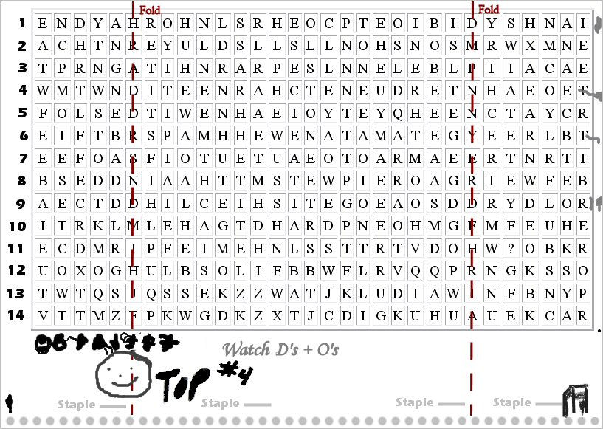
http://www.thekryptosproject.com/media/stills/images/one.jpg

Left Side is Sanborn K3 after folding. Right Side is K4, including the "?" from K3...
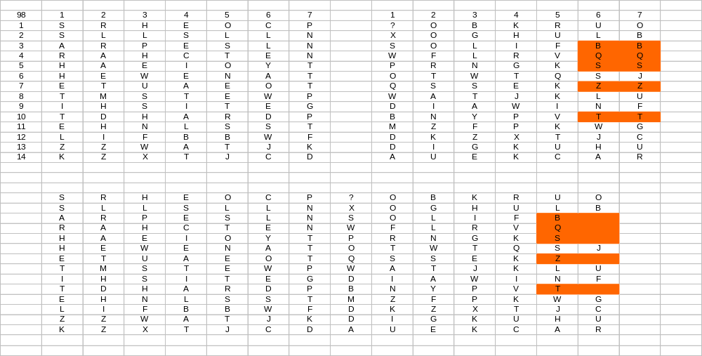

The double letters line up perfectly, and on the right side, like Zola.

I am curious if the 2 segments can combine to do something.

Note that: left side = 98; right side = 98
Combined = 196
Removing the (5) duplicates like Zola leaves 191 characters.

When I enter 191 into Groups.io search box, #5489
the author talks about using 191 (to solve K3 in a different way?), but she could not figure out where 191 could come from.

Lastly,

The Zola Right side in yellow seems to say "SOL I SEE T".

The Kryptos K3 Left-side segment Column 5 says, "OLSTONEET"

These might be related to "LODESTONE".

Maybe this will spark something in someone.
/

